<https://www.hacksplaining.com/exercises/sql-injection>

the tutorial is on the website

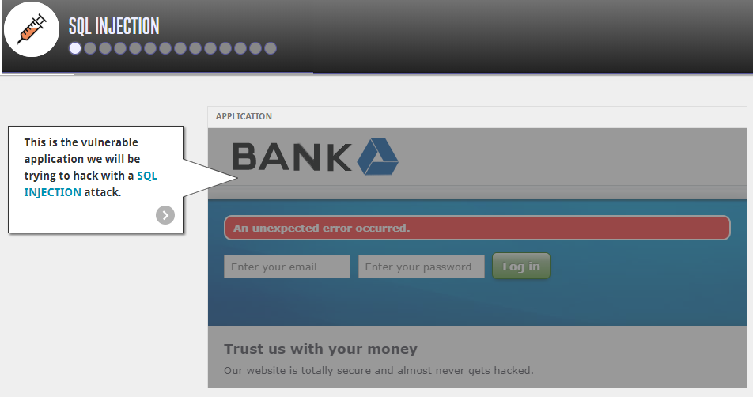

This website also can be tested

<https://sqlzoo.net/hack/>